**Portable Gaming Console with ESP32-WROVER, TFT Display, and MicroSD Storage**

**Description:**

The circuit is centered on an ESP32-WROVER-I microcontroller. The main power supply for the system is 3.3V.

The design integrates several key peripherals for operation. It includes a TFT screen for graphics display, managed through multiple GPIO connections of the microcontroller. For user input, the system features a series of buttons, including direction controls (up, down, left, right), action buttons (Start, Select, A, B), and menu buttons, which connect to a PCF8574 I/O port expander.

Data storage is handled through a MicroSD card slot with push-out functionality, allowing the reading and writing of information. Additionally, the circuit incorporates an auto-reset section for the microcontroller. Test points (TP1, TP2, TP3, TP4) are also included for monitoring key voltages such as V_USB, V_BATT and 3.3V.

Improvements were made to the original design in terms of protection and usability, such as the incorporation of an overcurrent protection circuit and a dual LED system that reports both the charging status and the low battery level. These improvements not only enhance the safety of the device but also optimize the end-user experience.

**Key Functions:**

* **Core Processing (Microcontroller):** The central component is an **ESP32-WROVER-I** microcontroller, which

runs the main logic, processes inputs, and controls all other peripherals.

* **Visual Output (TFT Display):** A **TFT Display** module is used for rendering all visual elements like menus and gameplay. It interfaces directly with the microcontroller's GPIO pins.
* **User Input:** The device accepts user commands through a set of physical buttons. This includes directional buttons (UP, DOWN, LEFT, RIGHT), action buttons (A, B), and function buttons (START, SELECT, MENU). Many of these inputs are managed by a **PCF8574** I/O expander to save microcontroller pins.
* **Data Storage:** A **MicroSD card slot** with push-out functionality provides external storage. This is used for storing game files, saved data, and other assets.
* **Power Management:** The circuit is designed to be powered from a USB source (**V_USB**) or a battery (**V_BATT**). The main operational voltage for all key components is **3.3V**.
* **Auto-Reset Circuitry:** A dedicated circuit provides an automatic reset function for the microcontroller, controlled by the DTR and RTS signals, which is common for programming.

**Power Tree:**

▶ Power Source (USB / Battery)

└───▶ Power Systems & Protections

│

├───▶ Charging Circuit (e.g., TP4056)

│ │

│ ├───> Charges the Li-Po Battery (3.7V)

│ │

│ └───> Status LEDs (Charging / Full)

│

└───▶ 3.3V Voltage Regulator

│

└───▶ Main Power Rail (3.3V)

│

├─▶ B. Processing & Storage

│ ├─ Microcontroller (ESP32)

│ └─ Storage (MicroSD Slot)

│

├─▶ C. Output (Display & Audio)

│ ├─ Display (TFT)

│ └─ Audio Output (DAC / Amp)

│

├─▶ D. Inputs & Controls

│ ├─ I/O Expander (I2C)

│ └─ Auto-Reset Circuit

└─▶ E. Debug & Programming

└─ USB to UART Interface

**Input Source:** Power originates from either a USB connection or a Li-Po Battery.

**Charging & Protection:** This input power feeds a charging circuit, which manages battery charging and provides a regulated output. This stage also powers the status LEDs.

**Main Regulation:** Power from the battery or charging circuit is routed to the 3.3V Voltage Regulator. This is the core of the power system, converting the variable battery voltage (typically 3.0V-4.2V) into a stable, constant 3.3V.

**Distribution:** The 3.3V rail distributes power to all active modules in the device: the microcontroller, display, audio circuitry, SD card slot, I/O expander, and the programming interface.

**Power Budget:**

The system can be powered by a **USB** connection or a **Li-Po battery**. The input power goes through a protection and charging circuit. A central **3.3V voltage regulator** then takes this power and supplies a stable 3.3v to all the main components. These components include the **ESP32 microcontroller**, the **TFT display**, the **audio output**, the **MicroSD slot**, and the input/control circuits.

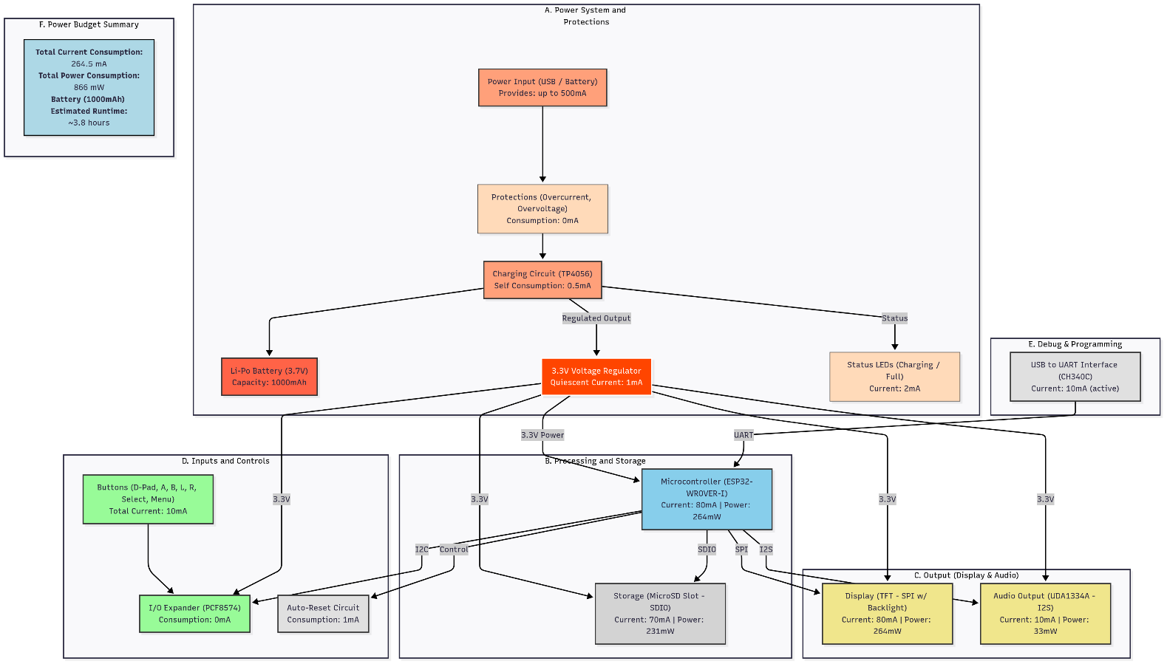

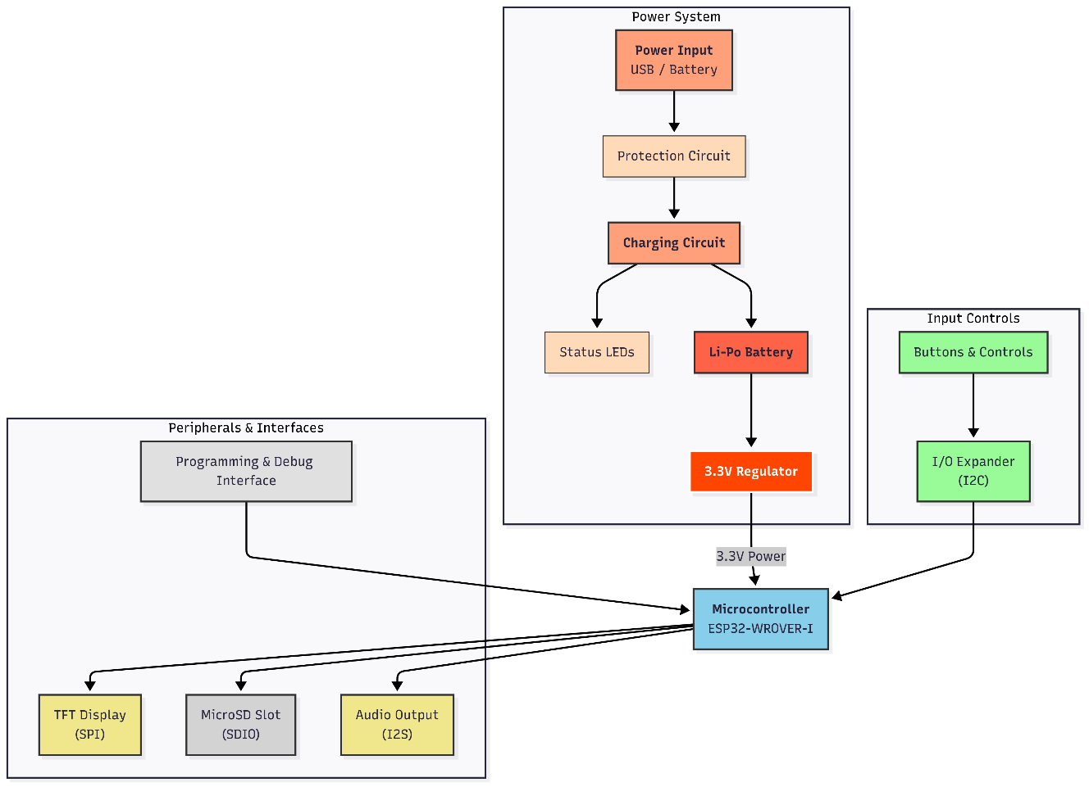**Block Diagram:**

**Bill of Materials:**